from django.shortcuts import render

def magazine_cover(request):
context = {}
if request.method == 'POST':
context['image'] = request.POST.get('image')
context['bg_color'] = request.POST.get('bg_color')
context['font_size'] = request.POST.get('font_size')
context['font_color'] = request.POST.get('font_color')
context['font_family'] = request.POST.get('font_family')
context['message'] = request.POST.get('message')

return render(request, 'index.html', context)
{% load static %}
<!DOCTYPE html>
<html lang="en">
<head>
<meta charset="UTF-8">
<title>Magazine Cover Generator</title>
<link rel="stylesheet" type="text/css" href="{% static 'coverapp/styles.css' %}">
</head>
<body>
<div class="container">
<h1>Magazine Cover Generator</h1>
<form method="post">
{% csrf_token %}
<div class="form-group">
<label for="image">Select Cover Image:</label>
<select name="image" id="image">
<option value="cover1.jpg">Cover 1</option>
<option value="cover2.jpg">Cover 2</option>
<option value="cover3.jpg">Cover 3</option>
</select>
</div>
<div class="form-group">
<label for="bg_color">Background Color:</label>
<input type="color" id="bg_color" name="bg_color" value="#ffffff">
</div>
<div class="form-group">
<label for="font_size">Font Size (px):</label>
<input type="number" id="font_size" name="font_size" value="24">
</div>
<div class="form-group">
<label for="font_color">Font Color:</label>
<input type="color" id="font_color" name="font_color" value="#000000">
</div>
<div class="form-group">
<label for="font_family">Font Family:</label>
<select name="font_family" id="font_family">
<option value="Arial, sans-serif">Arial</option>
<option value="'Times New Roman', serif">Times New Roman</option>
<option value="'Courier New', monospace">Courier New</option>
</select>
</div>
<div class="form-group">
<label for="message">Magazine Title/Message:</label>
<input type="text" id="message" name="message" placeholder="Enter your magazine title/message" required>
</div>
<button type="submit">Generate Cover</button>
</form>

{% if message %}
<!-- Magazine Cover Display -->
<div class="magazine-cover" style="background-color: {{ bg_color }};">
<img src="{% static 'coverapp/images/' %}{{ image }}" alt="Magazine Cover Image">
<div class="cover-text" style="font-size: {{ font_size }}px; color: {{ font_color }}; font-family: {{ font_family }};">
{{ message }}
</div>
</div>
{% endif %}
</div>
</body>
</html>

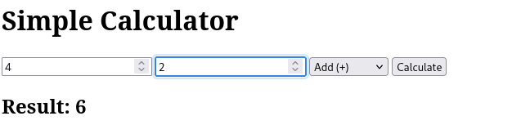
from django.shortcuts import render

def magazine_cover(request):
context = {}
if request.method == 'POST':
context['image'] = request.POST.get('image')
context['bg_color'] = request.POST.get('bg_color')
context['font_size'] = request.POST.get('font_size')
context['font_color'] = request.POST.get('font_color')
context['font_family'] = request.POST.get('font_family')
context['message'] = request.POST.get('message')

return render(request, 'index.html', context)
{% load static %}
<!DOCTYPE html>
<html lang="en">
<head>
<meta charset="UTF-8">
<title>Magazine Cover Generator</title>
<link rel="stylesheet" type="text/css" href="{% static 'coverapp/styles.css' %}">
</head>
<body>
<div class="container">
<h1>Magazine Cover Generator</h1>
<form method="post">
{% csrf_token %}
<div class="form-group">
<label for="image">Select Cover Image:</label>
<select name="image" id="image">
<option value="cover1.jpg">Cover 1</option>
<option value="cover2.jpg">Cover 2</option>
<option value="cover3.jpg">Cover 3</option>
</select>
</div>
<div class="form-group">
<label for="bg_color">Background Color:</label>
<input type="color" id="bg_color" name="bg_color" value="#ffffff">
</div>
<div class="form-group">
<label for="font_size">Font Size (px):</label>
<input type="number" id="font_size" name="font_size" value="24">
</div>
<div class="form-group">
<label for="font_color">Font Color:</label>
<input type="color" id="font_color" name="font_color" value="#000000">
</div>
<div class="form-group">
<label for="font_family">Font Family:</label>
<select name="font_family" id="font_family">
<option value="Arial, sans-serif">Arial</option>
<option value="'Times New Roman', serif">Times New Roman</option>
<option value="'Courier New', monospace">Courier New</option>
</select>
</div>
<div class="form-group">
<label for="message">Magazine Title/Message:</label>
<input type="text" id="message" name="message" placeholder="Enter your magazine title/message" required>
</div>
<button type="submit">Generate Cover</button>
</form>

{% if message %}
<!-- Magazine Cover Display -->
<div class="magazine-cover" style="background-color: {{ bg_color }};">
<img src="{% static 'coverapp/images/' %}{{ image }}" alt="Magazine Cover Image">
<div class="cover-text" style="font-size: {{ font_size }}px; color: {{ font_color }}; font-family: {{ font_family }};">
{{ message }}
</div>
</div>
{% endif %}
</div>
</body>
</html>
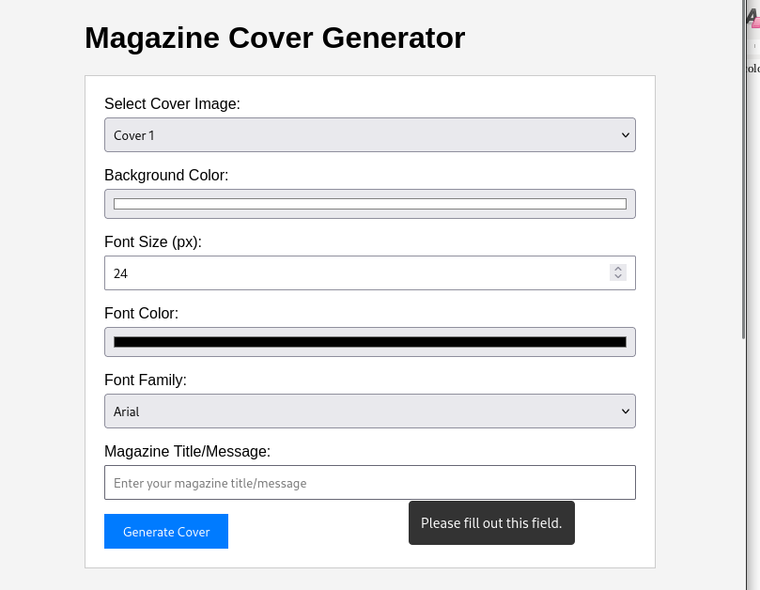
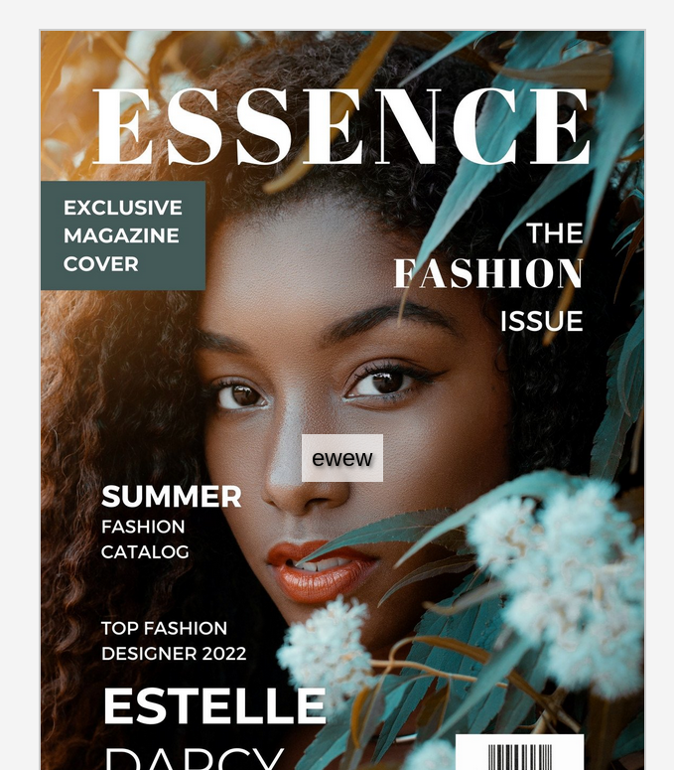
from django.shortcuts import render

def home(request):
return render(request, 'home.html')

def metadata(request):
return render(request, 'metadata.html')

def reviews(request):
return render(request, 'reviews.html')

def publisher(request):
return render(request, 'publisher.html')
{% load static %}
<!DOCTYPE html>
<html lang="en">
<head>
<meta charset="UTF-8">
<title>Book Information</title>
<link rel="stylesheet" href="{% static 'bookinfo/styles.css' %}">
</head>
<body>
<h1>Welcome to the Book Information Page</h1>
<!-- Display the book cover -->
<img src="{% static 'bookinfo/images/book_cover.jpg' %}" alt="Book Cover" style="width:300px;height:auto;">

<!-- Navigation links -->
<nav>
<ul>
<li><a href="{% url 'metadata' %}">Metadata</a></li>
<li><a href="{% url 'reviews' %}">Reviews</a></li>
<li><a href="{% url 'publisher' %}">Publisher Info</a></li>
</ul>
</nav>
</body>
</html>

{% load static %}
<!DOCTYPE html>
<html lang="en">
<head>
<meta charset="UTF-8">
<title>Metadata</title>
<link rel="stylesheet" href="{% static 'bookinfo/styles.css' %}">
</head>
<body>
<h1>Book Metadata</h1>
<p><strong>Title:</strong> The Great Adventure</p>
<p><strong>Author:</strong> Jane Doe</p>
<p><strong>ISBN:</strong> 123-4567890123</p>
<p><strong>Published:</strong> 2025</p>
<a href="{% url 'home' %}">Back to Home</a>
</body>
</html>

